Fertilizers Recommendation System For Disease Prediction

Agriculture is the main aspect of the economic development of a country. Agriculture is the heart and life of most Indians. By understanding their feelings and problems, we can create a better product and contribute to their lives. For our project, we are getting surveys from farmers to understand what they truly require and desire.

It simplifies the farmer's work.

## This is a textbox...

"This is more helpful in identifying the disease in the crop and makes us more profit."

It Unlocks A New Level Of Modern Agriculture

It improves quality and quantity.

Increasing Your Knowledge About Plant Diseases and Fertilizers

It replaces the agricultural experts.

It makes the farmer as smart as possible.

"It is far better than traditional analysis techniques."

"Making revolutionary changes in farming industry."

It eliminates a time- consuming process.

"Preparations that are simple to make."

"Fix Our Problems from Early Stages With This Application."

Sleek User Interface

"Easy and user- friendly."

Improving productivity and efficiency

assisting in making better farm management decisions.

It has accelerated the agricultural process.

It can reduce a man's power.

### providing data security.

Instant Solution

#### "It reduces the complexity of disease prediction."

"We get a clear report that gives us a better understanding of the problem."

"The cost for using this service is less."

promoting a healthy lifestyle for the former.

User- Friendly Application

multilingual application

"It will save us time."

People with no prior knowledge can access

Upgration of the Industry with this Application

reducing pests and diseases.

Before applying a new technology farmers should fully understand the risk.

" I will try this and compare with actual outcome and Predicted one "

It reduces the intraction between humans.

time efficient

One of the most efficient and rapid methods of disease detection

self-working environment

constancy of constant work.

Not Accurate at All the time Due to Lack of Data

"Can this application take responsibility for the losses that may happen due to this application?"

"It is such a good application for farmers and it will make them profitable in their business."

Improves Productivity

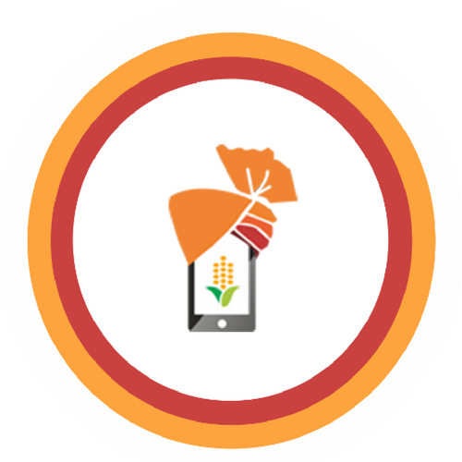

Better Utilization of Available Resources

available around the clock

reduce the likelihood of a loss.

"Can you guarantee the accuracy of this application?"

"How can I trust a machine for my business?"

"If it makes a wrong prediction, it leads to a huge loss."

The reduction of human risk by ensuring that

# Is it reliable ?

Not all people trust the recommendation systems.

Crop prediction accuracy, disease and correct fertilizer recommendations

A small error in the algorithm or data results in a large amount of loss.

It may lead to the wrong prediction.

# Some people's fears about "is it actually works"

Is Recommended Fertilizer Available in the Users' Location?

# Early detection & management of problems